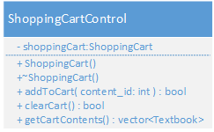

The ShoppingCartManagment subsystem provides one service, the ability to retrieve the contents of the shopping cart. This services is provided by the function, getCartContents(), which returns a vector of textbooks.

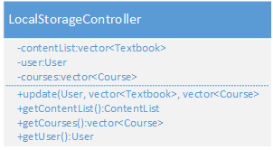

The LocalStorageManagment subsystem provides two services. The service LocalStorageUpdater is provided by the function update(User, vector<Textbook>, vector<Course>). This function updates the localstorage with the current content associated with the user and the courses that the user is enrolled in. If the user is a content manager they are considered to be enrolled in all of the courses and can see all of them.

LocalStorageManagment also provides the LocalStorageSource service. This service is provided by the functions get ContentList(), getCourses(), and getUser(). These functions allow other subsystems to retrieve the information currently kept track of on the client.

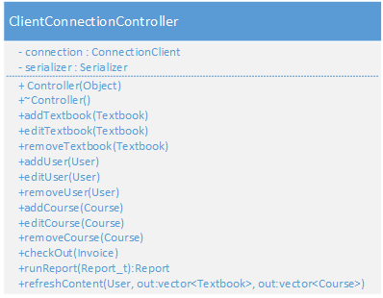

The Storage subsystem also has two services. The PersistentStorageUpdater service provides the functions, addTextbook(), addUser(), addCourse(), editTextbook(), editUser(), editCourse(), removeTextbook(), removeUser(), removeCourse(), and checkout(). These functions provided by the class ClientConnectionController give the ability to change the contents of the persistent storage. The service, PersistentStorageSource, provides the functions, refreshContent(), and runReport. Refresh content takes the currently logged in User and returns the list of courses they are enrolled in and the textbooks associated with those courses. The report takes the wanted report type and returns the request report.

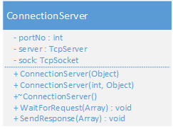

The ServerStorageManagement subsystem provides the same services as the ClientStorageManagement subsystem. All of the operations provided that are part of the services of ClientStorageManagement are passed to the ConnectionServer. The function WaitForRequest() receives the intent of the client and sendResponse() sends the response.